University of Petroleum and Energy Studies
School of Computer Science
Department of Cybernetics

Graphics & Animation Tools
LAB FILE
(Session: 2020-2021)

Course: B. Tech with Specialization in Open Source and Open Standards

Submitted To- Submitted By-
Dr. Durgansh Sharma Rahul Raj Baranwal
Associate Professor SAP ID -500061624
Department of Cybernetics Roll No. -R100217054

Experiment- 9 Design of 3D Mountain Landscape using Blender.

In this experiment we need to create a 3D Mountain Landscape of our choice with the help of blender.
Step-1 Clear your default interface of blender which includes deletion of cube.
Step-2 Press Shift+A and go to landscape, and create a landscape on the screen
Step-3 Change the properties of landscape according to your need and provide more realistic shape and view for a mountain
Step-4 For creating field view in front of mountains, we can take the plane surface in front of the mountain, and extrude at a few places to give it a look of rough surface.
Step-5 Take a few cubes on the plane and extrude its surface from a few places to give it a shape of rocks
Step-6 For creating trees in the field take a cone and extrude its side from all direction to give it a shape branch
Step-7 Copy the step-7 and create multiple little trees in the fields for better look.
Step-8 Now for the colouring part, go into the edit mode again, and select the faces you want for one colour, and click the + button in the materials section
Step-9 This will apply the colour to all faces, next click on another face, click the + button, and click Assign, this will give the selected face the new material.
Step-10 Finally export your files as .blend file and also render a few images for the reference purpose.

Output (Rendered Images):
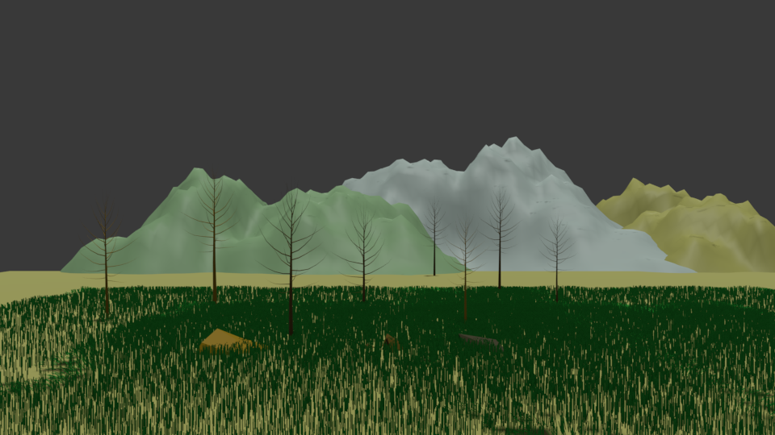
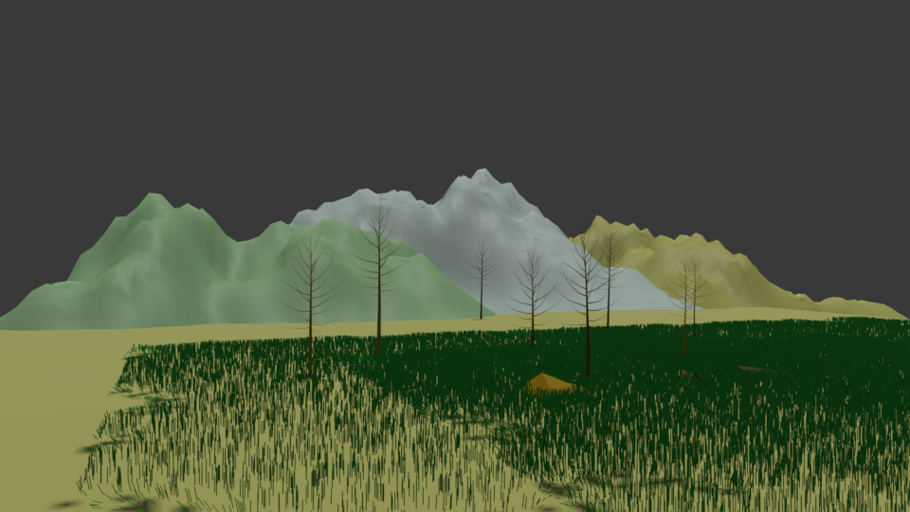
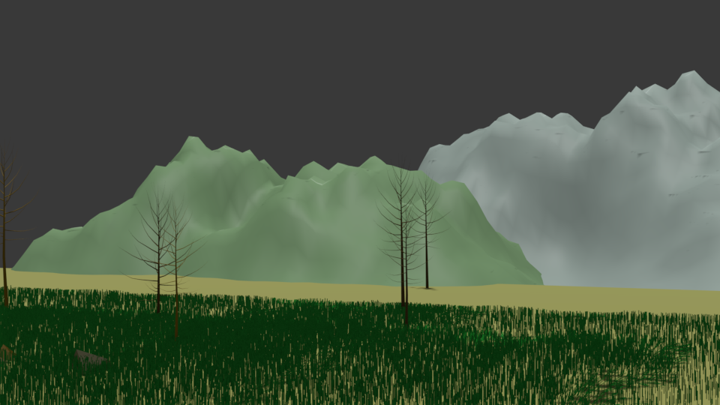
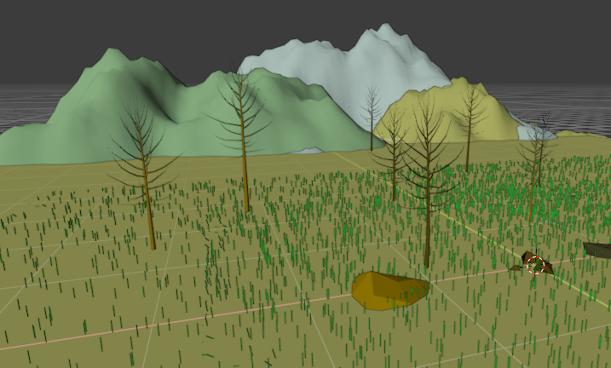

Link for the blender files and Rendered Images:

